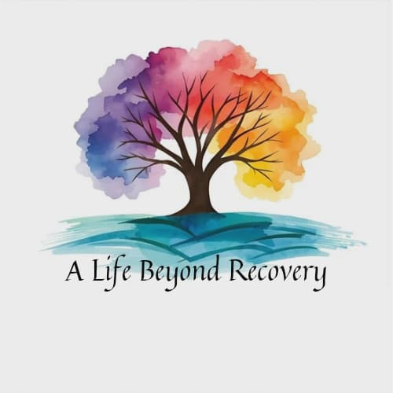
A Life Beyond Recovery, LLC
The Cornerstone Lodge

Welcome Letter
Dear Resident,
Welcome to our home. By choosing to walk through these doors, you’ve taken a courageous step toward healing, hope, and a new beginning. We know that recovery is not always easy, but you are not alone anymore. Here, you are part of a community that believes in you, supports you, and walks beside you on this journey.
Our home is built on compassion, accountability, and respect. Each person who lives here contributes to the strength of this community. Together, we create a safe space where honesty, responsibility, and growth are encouraged and celebrated.
We believe that recovery is more than just living substance-free — it’s about rediscovering yourself, building healthy connections, and creating a future filled with purpose. Every day here is an opportunity to learn, to heal, and to grow stronger.
As you begin this chapter, remember:
• You are worthy of recovery.
• You are capable of change.
• You are not alone.
We are honored to walk with you on this path.
With respect and encouragement,
A Life Beyond Recovery, LLC Managers

Section 2: Intake Application
Date of Application: Staff Initials:

1. Personal Information
Name:
Date of Birth: Social Security Number:
Phone Number: Race: Ethnicity:
Primary Language:
Aliases/Nicknames:
Emergency Contact Name:
Phone Number: Relationship:

2. Shelter Status
Address:
Have you ever been unsheltered or living in temporary shelter?
If so, how long ago and for how long?

3. Education
Highest Level of Education Completed:
Degrees or Certificates:

4. Employment & Skills
Most Current Employment:
Employment Skills:

5. Parental Status
Number of Children: Do you have custody of them:
Do you receive child support: Do you pay child support:
Are you involved in a custody suit:

6. Legal Issues
Do you have a Guardian: If so, who:
Are you on Probation/Parole: Officer:
Are you in Treatment Court: District/County:
Pending Charges:

7. Insurance
Type of Insurance: Policy Number:
Insurance Name:

8. Medical & Mental Health
Medical Diagnoses:
Mental Health Diagnoses:
Prescribed Medications:
Allergies:
Disabilities:
Accommodations:

9. Community Resources
Are you receiving any of the following services:
Food Stamps: HUD: SSI: Daycare:

10. Substance Use History
Date of Last Use: Sobriety Date:
Substance(s) of Choice:
Substitute Substances:
Age you started using: Do you have a Sponsor:
Previous Treatment/Detox:

11. Housing & Recovery Readiness
Goals while in housing:
Strengths you bring:
Challenges you anticipate:
Willing to follow house rules & engage: Will you be honest:
Are you able to pay the program fees: Are you open to help:
Why are you applying here:

I certify the above information is true and correct. I understand that A Life Beyond Recovery, LLC (The Cornerstone Lodge) requires expulsion, without notice or appeal, of any Resident that is found to be using any prohibited substance, commits violence or threatens violence or engages in any type of sexual relationships and/or sexual harassment with another Resident or Staff. I further understand I must submit and pass a drug screen prior to being admitted into The Cornerstone Lodge. I hereby waive any landlord/tenant rights in order to gain residency into The Sunflower House.
Applicant Signature: Date:
Applicant Printed Name:

Staff #1 Signature: Date:
Staff #1 Printed Name:

Staff #2 Signature: Date:
Staff #2 Printed Name:

Approved: Denied:

Section 3: House Rules & Expectations

Sobriety & Recovery
- No drugs, alcohol, or mood-altering substances on the premises.
- Random drug/alcohol testing required.
- Relapse/rule violations reviewed by staff; may result in discharge.
- Must attend at least one, in person offsite recovery meetings per week.

Respect & Community Living
- Treat everyone with respect and dignity.
- Quiet hours: 10:00 PM – 7:00 AM.
- No overnight guests and all visitors must be pre-approved by staff.

Chores & Responsibilities
- Participate in household chores.
- Keep personal and shared areas clean.
- Must attend house meetings.

Employment, School, & Structure
- Must engage in work, school, or volunteer activity within forty-five (45) days.
- Curfew: 9:00 PM unless permission has been given beforehand.

Health & Safety
- No weapons.
- Smoking/vaping in designated areas only.
- Medications stored per policy.
- Passes will be granted on a case-by-case basis but not within the first 90 days.
- Blackout period of 14 days where no phone or video calls can be made upon entry to the house.
- Visitors may be pre-approved for on-site visits after thirty (30) days.

Financial Agreement
- Program fees are due every Saturday by 10:00 AM.

Resident Signature: Date:

Staff Signature: Date:

Section 4: Resident Rights & Responsibilities

Resident Rights
- Safe, substance-free environment.
- Dignity, respect, and non-discrimination.
- Privacy within guidelines.
- Support in recovery and personal growth.
- Right to voice concerns without retaliation.

Resident Responsibilities
- Remain substance-free.
- Follow rules, schedules, and curfews.
- Respect others’ privacy and property.
- Participate in recovery, chores, and meetings.
- Be financially responsible.
- Handle conflicts constructively.

Resident Signature: Date:

Staff Signature: Date:

